Shams Hamzazai Foundation (SHF)
Back Ground
Shams Hamzazai Foundation was established in December 2018 in Loralai district of Balochistan. Its founder is Shams Hamzazai and has a broad vision for the foundation. Basically, the Shams Hamzazai Foundation is working in various fields including health, education, social work, poverty reduction and sports. Shams Hamzazai Foundation is regularly registered with the Department of Industry and Commerce Balochistan, Balochistan Charity Registration and Regulation Authority (BCRA), Federal Board of Revenue (FBR) Balochistan. The Shams Hamzazai Foundation has formed social media groups, WhatsApp groups, websites and local committees at various levels.

Vision
Strengthening Communities of Balochistan in shaping their lives through Activism and Technology

Mission
Transforming the lives of deprived people of Balochistan by empowering them and future generation

Objectives of SHF
- Promote basic Human Rights, particularly of women, minorities, indigenous communities, people living with disabilities, senior citizens, infant, child and adolescents
- Contribute to the creation of a tolerant society through the promotion of the value of peace, justices, freedom.
- Promote tolerance, interfaith harmony & social harmony.
- Promote democracy, freedoms, civic spaces& good governance in the society
- Mobilize stakeholders for vision Pakistan & sustainable development goals.
- Encourage and support democratic norms, values &institutions in the society;
- Incorporate humanism, feminism, gender sensitization in all program activities and to make gender a cross cutting theme.
- Protect climate change, forest, mountains, agriculture, bio diversity, environment, water conservation, natural resources management and promotion of WASH and WATSAN
- Promote good health, wellbeing, SRHR, ending HIV/AIDS, malaria, tuberculosis, HBC and early, child and forced marriages
- Increase literacy, enrolment & decreasing dropout trough quality education, innovative technologies & creating public private partnership development
- Strengthening, monitoring, evaluation, tracing, tracking through citizens generated data, transparency, accountability, ownership & open data mechanism
- Creation of employment opportunities for poor and needy
- Provision of alternate disputes resolutions (ADR) and legal aid to victims, survivors, poor, needy, neglected and suppressed
- Providing accelerated learning pathway (ALP)
- Provision of livelihood through interest free loan to the vulnerable groups
- Increasing women, youth & community participation
- Charity through community members will be done that will generate Endowment fund for poverty elevation from rural Balochistan
Core Values:

Respect:
We respect the values and the beliefs of the people with and for whom we work and we act in consideration of their environment. We care.

Integrity:
We adhere to strong principles; we take responsibility for our actions, processes and results, and we expect the same from our stakeholders. We honor our commitments.

Collaboration:
We believe we are more powerful when we work together within our team and with our partners. We all join forces for greater impact.

Innovation:
We are entrepreneurial; we have the courage and the creativity to pursue unique ideas that have the potential of pushing boundaries. We think outside the box and we make it happen.

Fun:
We aspire to connect, spread joy and excitement in everything we do. While having fun, we strive to achieve positive and sustainable results.

Offices

Committees Network in Pakistan
SHF has established six further committees in different area of the country for financial and technical assistance of the deprived people of the Balochistan, which is as follows.

Lahore Committee`s Orientation for Assistance
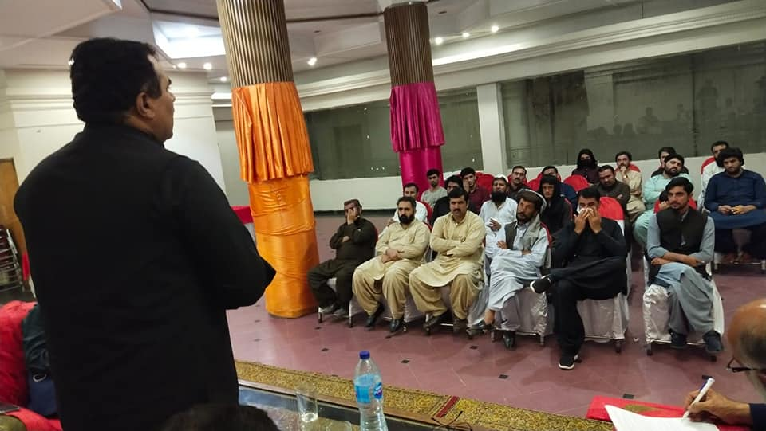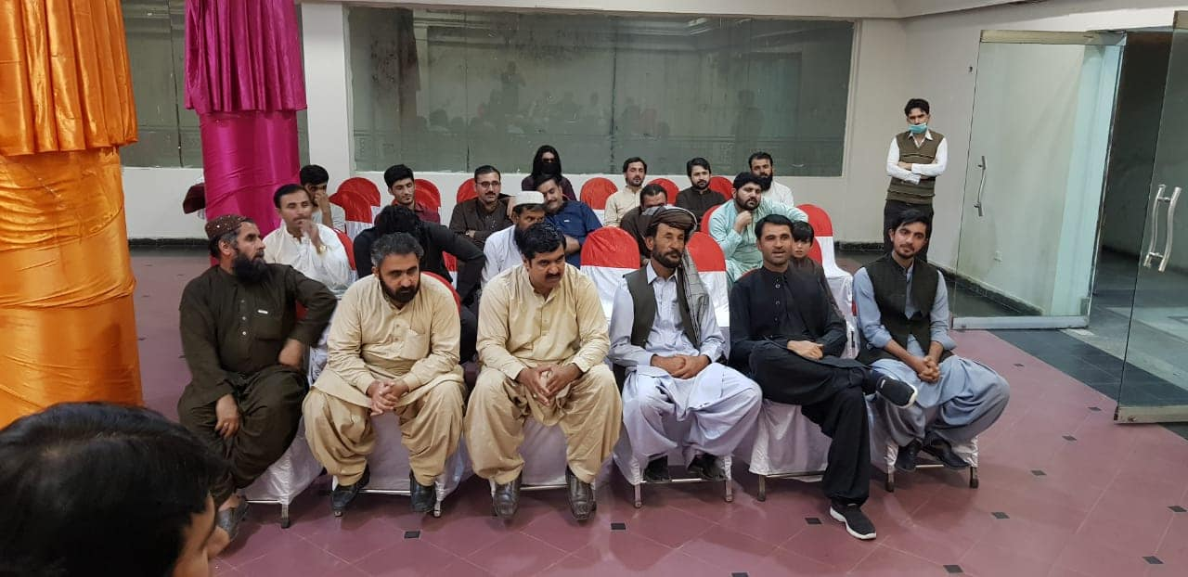
Multan Committee`s Orientation for Assistance
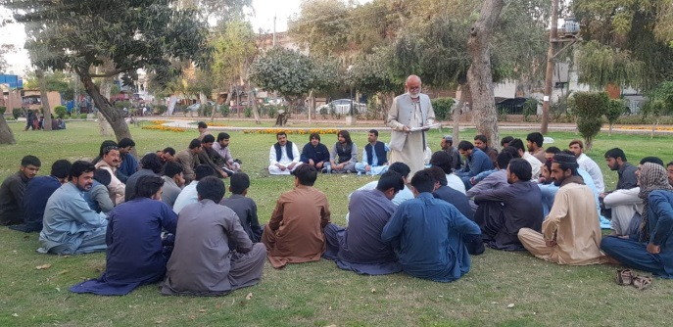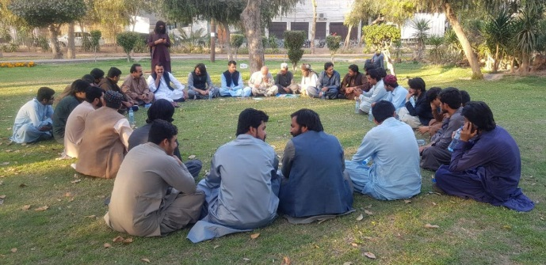
Islamabad Committee`s Orientation for Assistance
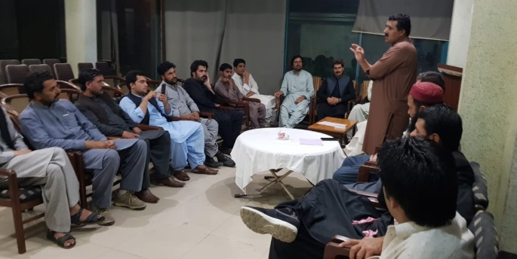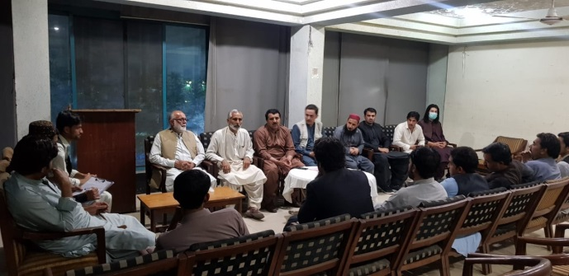
Duki Committee`s Orientation For Assistance
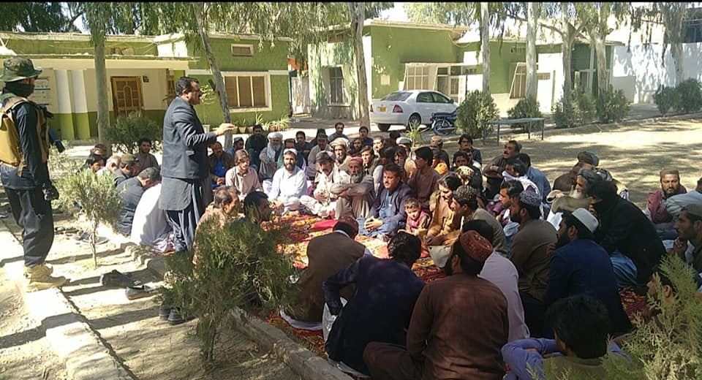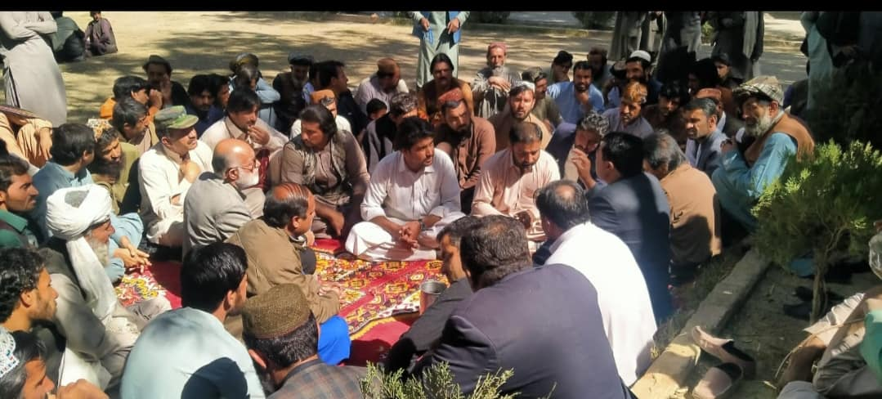

Dera Ghazi Khan Committee`s Orientation for Assistance
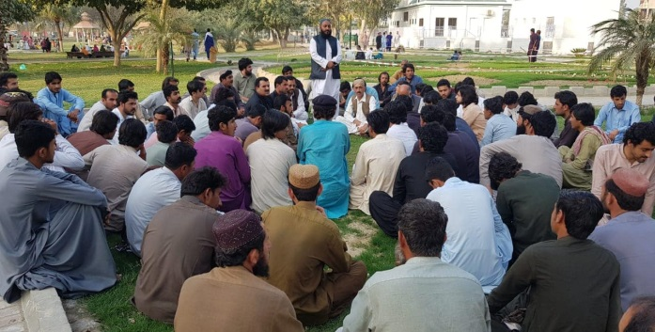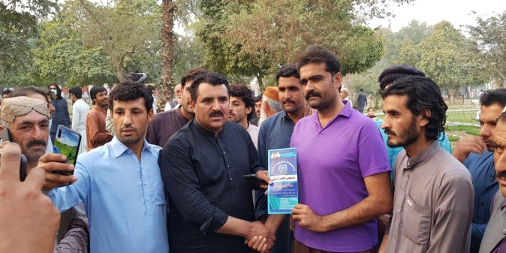
Quetta Committee`s Orientation for Assistance
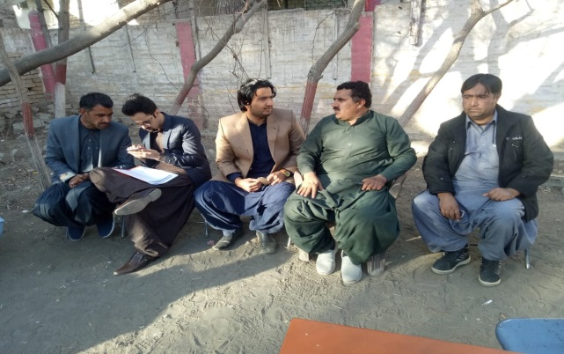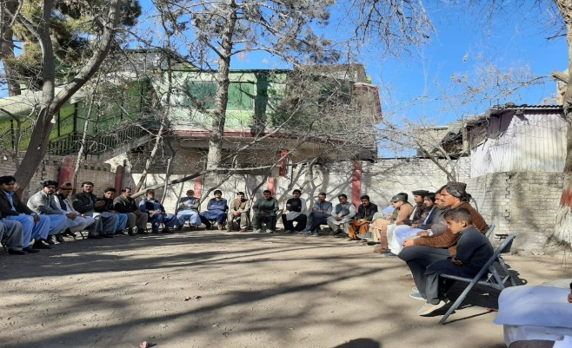
Loralai District Committees:
Shams Hamzazai Foundation (SHF) Have 368 local Communities in Loralai District which is manage through UC committees, the whole UC committees are directly Linked with District Committees and concerned office. The Structure of District committees are as Follows.

SHF UC Committees

UC Committees Meeting
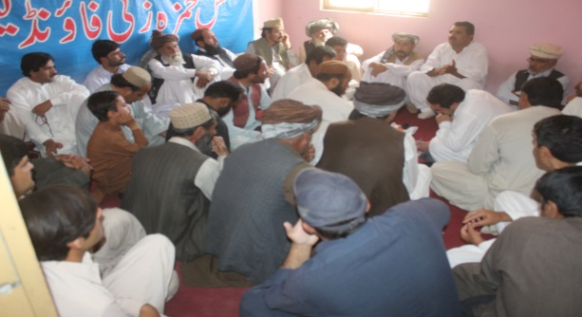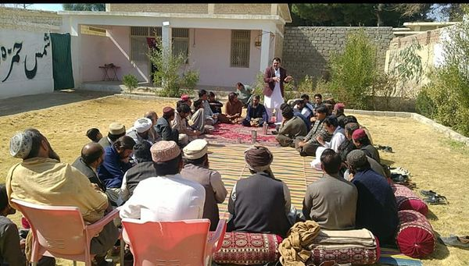
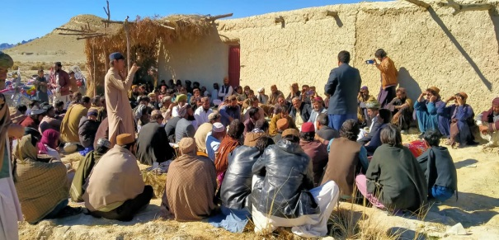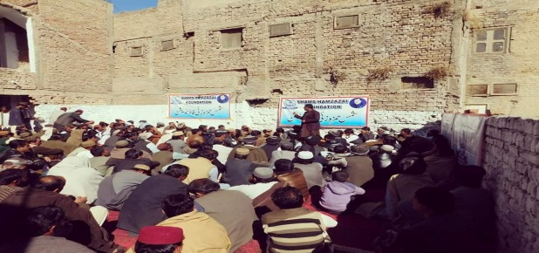
SHF General Body
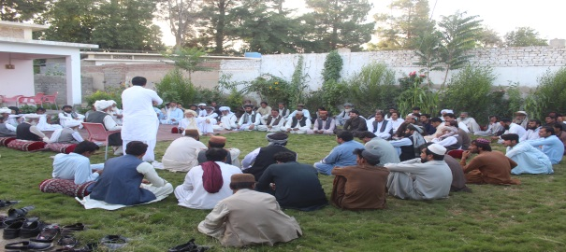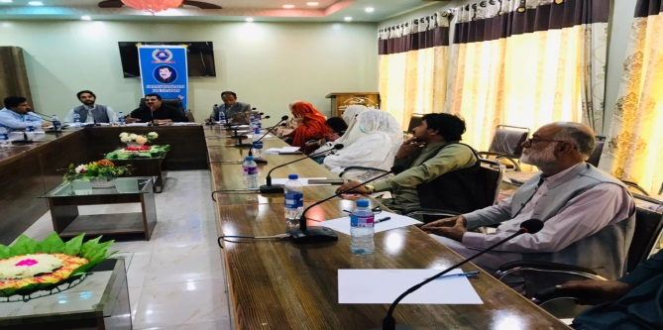

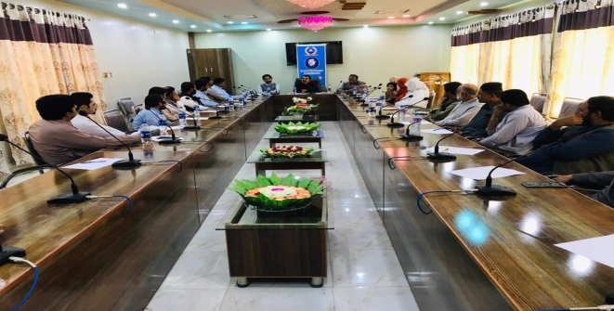

Workers Conventions
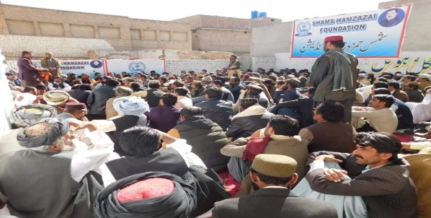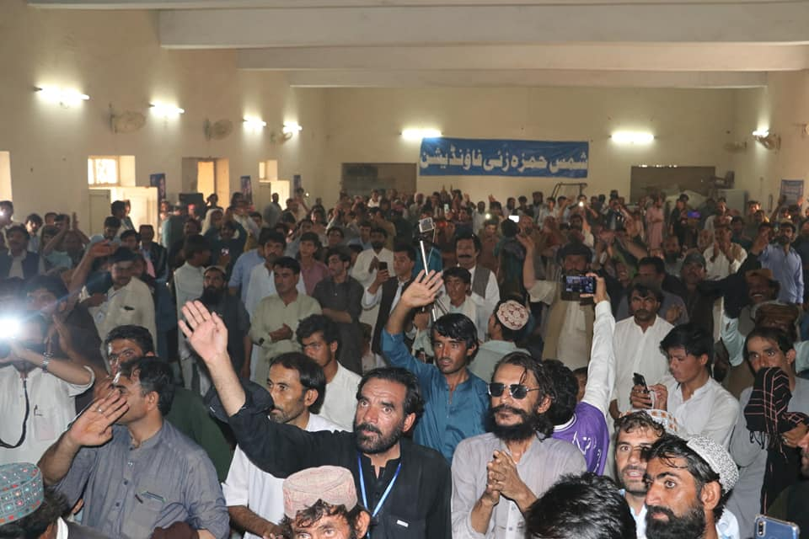

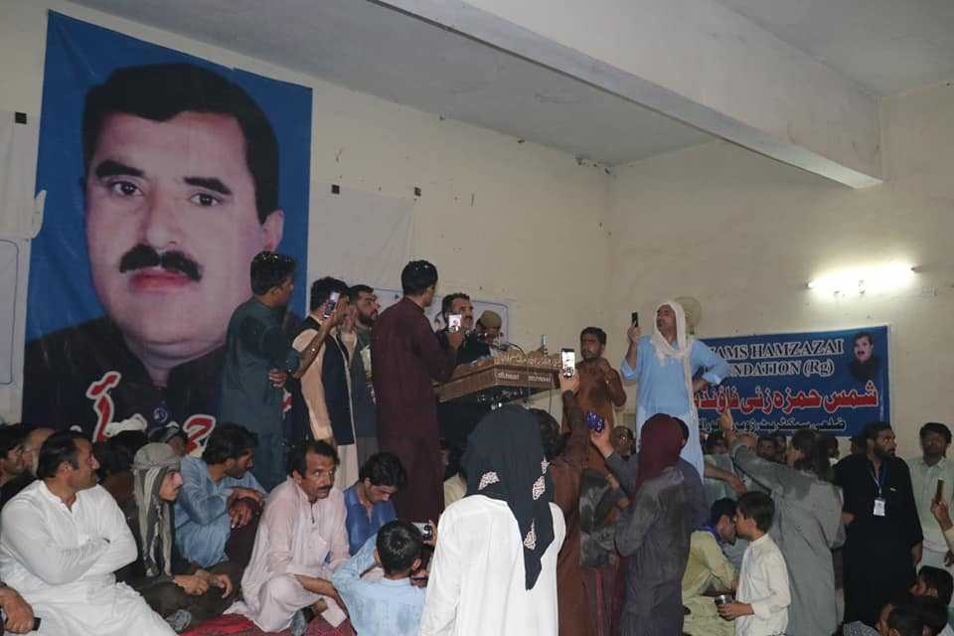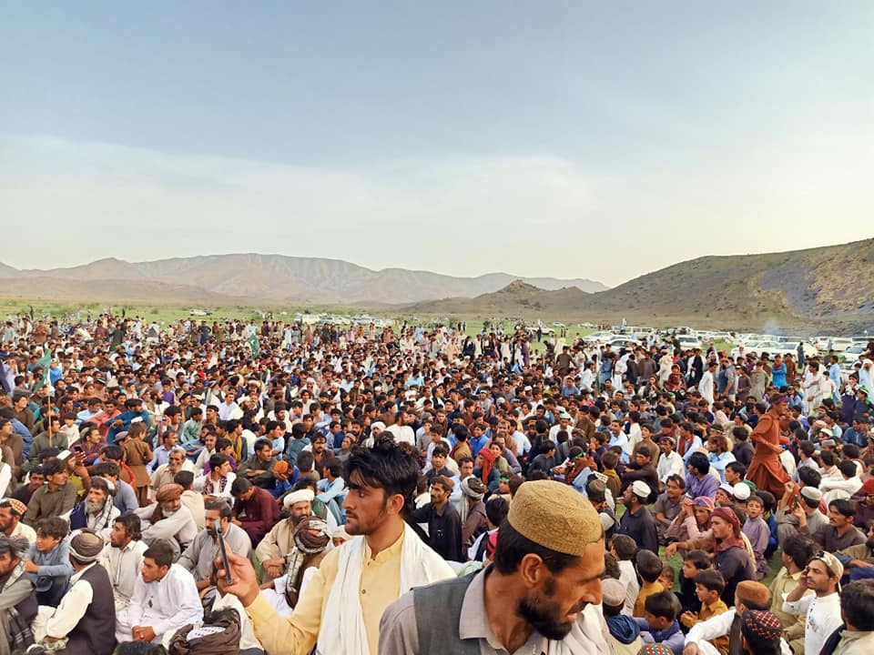

SHF BoD:
There are nine members of SHF Board of Directors which regulate the foundation. Regulatory body of the SHF is as follows.
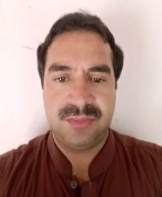 Mr. Jalal-ud-Din Chairman
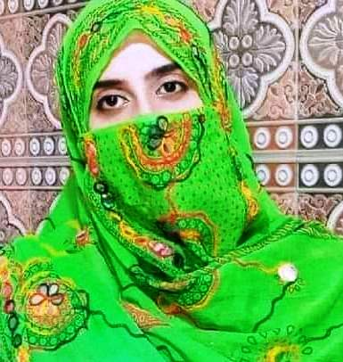 Ms. Razima Bibi Vice Chairman

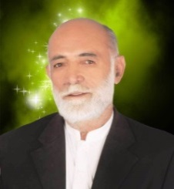 Mr. Mohammad Qayoum General Secretary

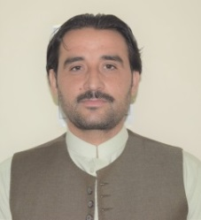 Mr. Mujeeb-u-Rahman Treasurer
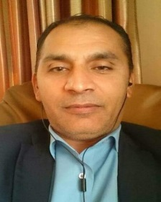 Abdul Rauf Chief Executive Officer (CEO)
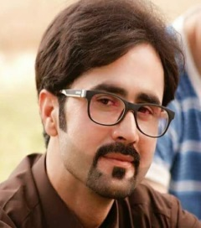 Mr. Mohammad Faheem Legal Advisor
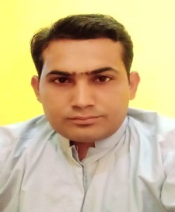 Mr. Kowar Lal Secretary of Minorities
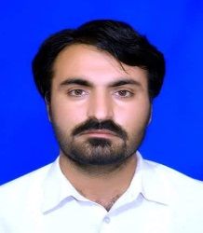 Mr. Abdul Wali Secretary of Press and Publication
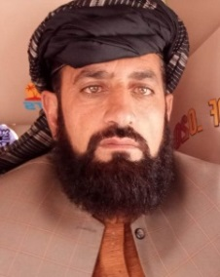 Mula Noor Mohammad Secretary Volunteers

FUNCTIONAL AREA

- Education
SHF has started 12 Alternate Learning Centers in different UC of the Loralai district, distributed 1500 School Bags with required books and tools. Free education has been provided to 70 poor children in various schools
- Schools List
S/No. | Name of Schools | Address
1 | SHF Alternate learning program Kiyari | Kili Kiyari Zara Barad Mekhtar Loralai
2 | SHF Alternate learning program Kashki | Kili Kashki Zara Barad Mekhtar Loralai
3 | SHF Alternate learning program Noshfa | Kili Noshfa Zara Barad Loralai
4 | SHF Alternate learning program Landai | Kili Landai barad, Zara Barad Loralai
5 | SHF Girls Alternate learning program Usman Ghani | Kili Usman Ghani Khan Gul Nali Mekhtar Loralai
6 | SHF Alternate learning program Ghara Nali Malazai | Kili Ghara Khan Gul Nali Mekhtar Loralai
7 | SHF Alternate learning program Sarhai | Kili Sarai toora thana Mekhtar Loralai
8 | SHF Alternate learning program Tarkha China | Kili Tarkha China Mekhtar
9 | SHF Alternate learning program Obloon Tarkha China | Kili Obloon Tarkha China Mekhtar
10 | SHF Alternate learning program Kili Safian | Kili Safian China Union Loralai.
11 | SHF Alternate learning program Sher Zaman Kach Nali | Kili Sher Zaman Kach Khan Gul Nali
12 | SHF Alternate learning program Gulam Jo Shekhan. | Kili Gulam Jo Shekhan New Wayala Aghbarg
13 | SHF Alternate learning program Soor Ghound | Kili Malak Maret Khan Soor Ghound Kachamaqzai, Loralai.
14 | SHF Alternate learning program Noshfa-2 | Kili Malak Garai Noshfa, UC Zara.Mekhtar.
15 | SHF Alternate learning program Faizu Nali Azam | Kili Faizu Nali Azam, UC Khan Gul Nali Mekhtar

- Books Distribution
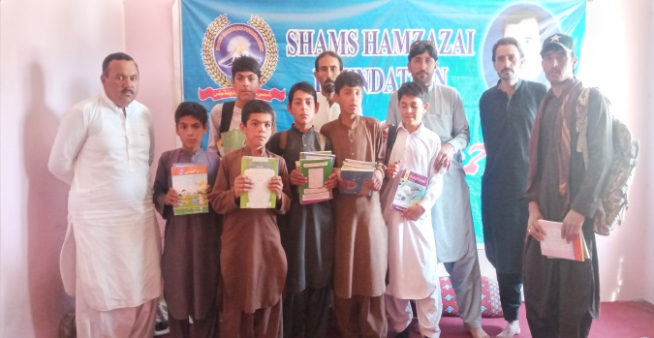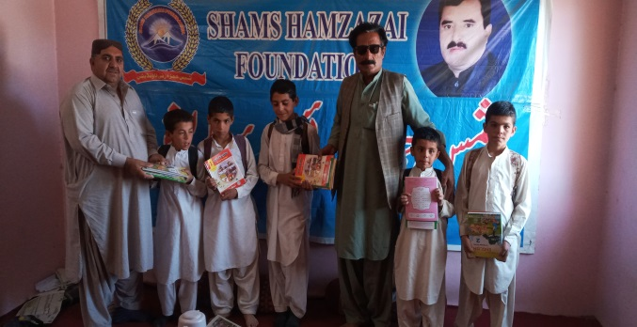
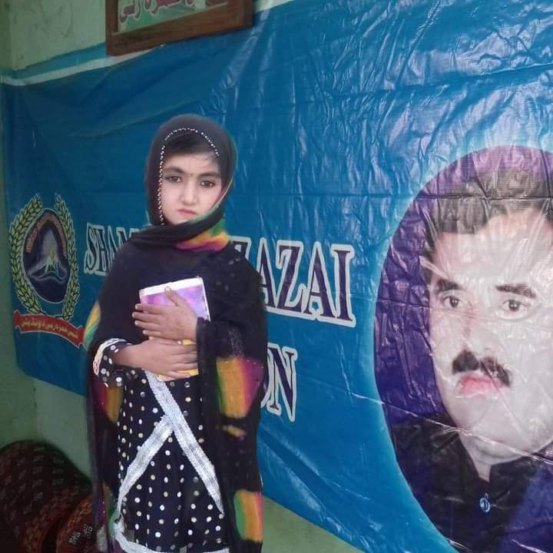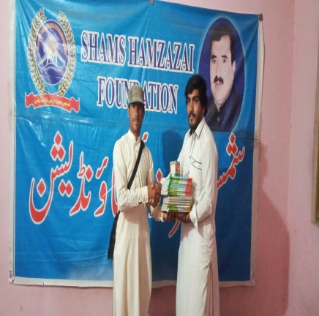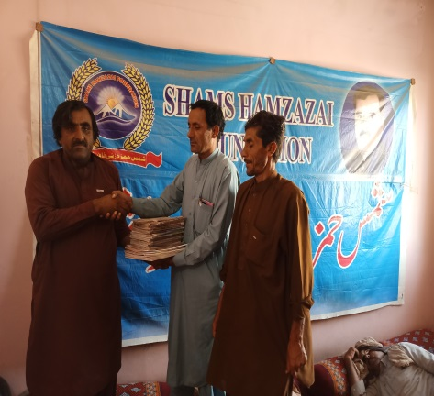

- School Pic.
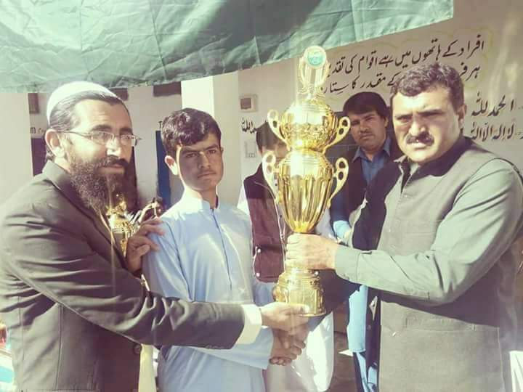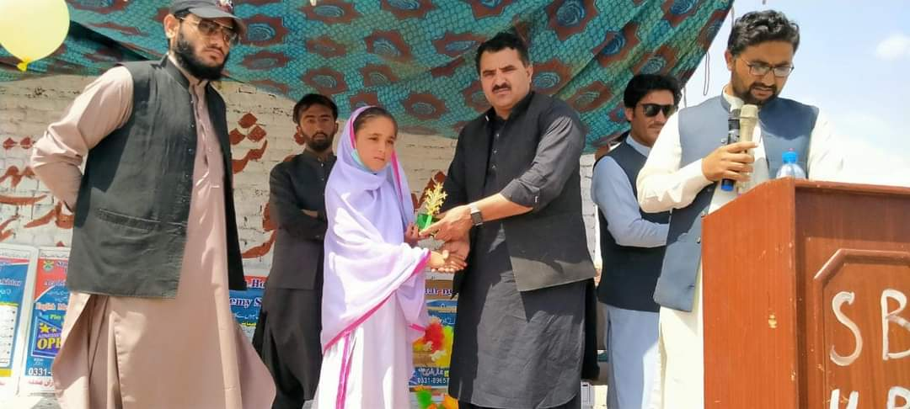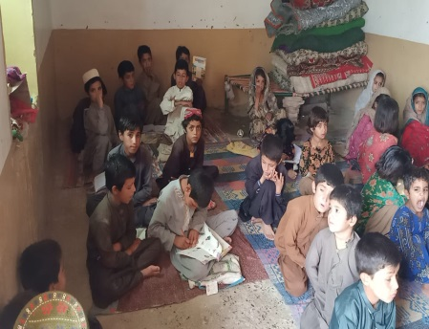
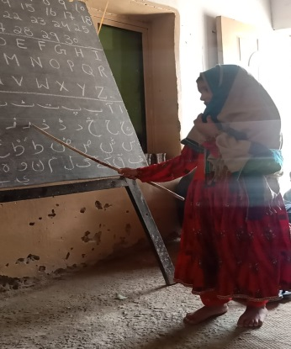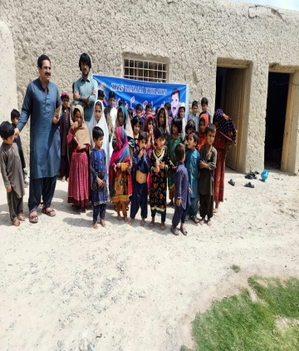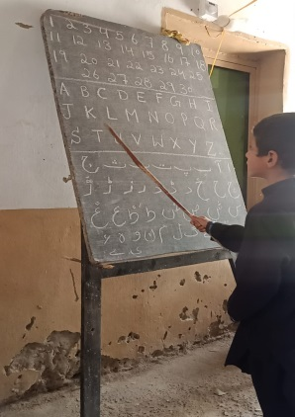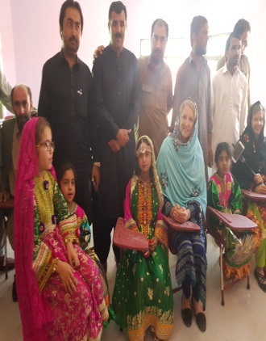

- Health
SHF have Donated 2700 blood bags, sponsored 84 eye operations and 250 eye checkup & medicines, 34 serious patients and deaths have sponsored ambulance facilities, 1300 patients financial and technical assistance for treatment and mobilization. Provides COVID-19 awareness in local communities of district, thousands of masks and sanitizers have distributed in the districts.
- Eye OPD and Eye Operations
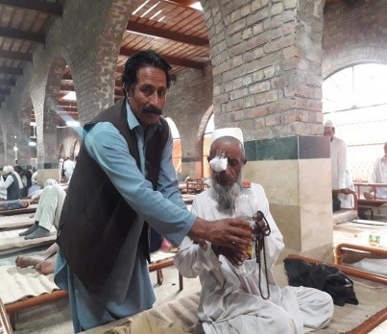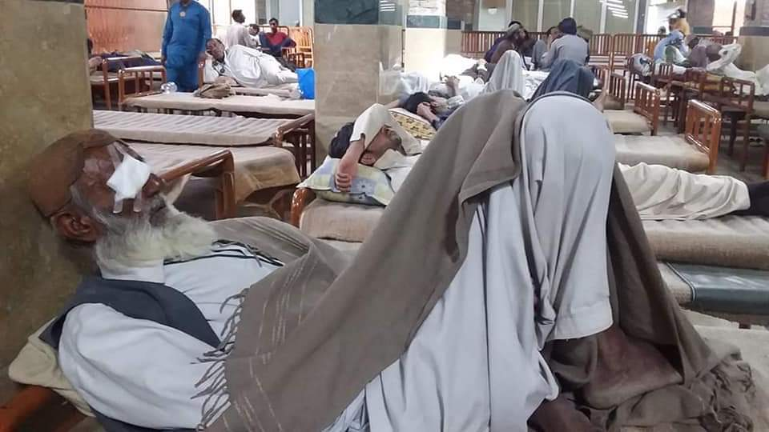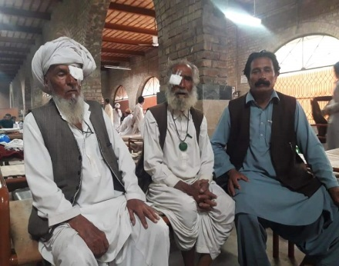
- Blood Donation
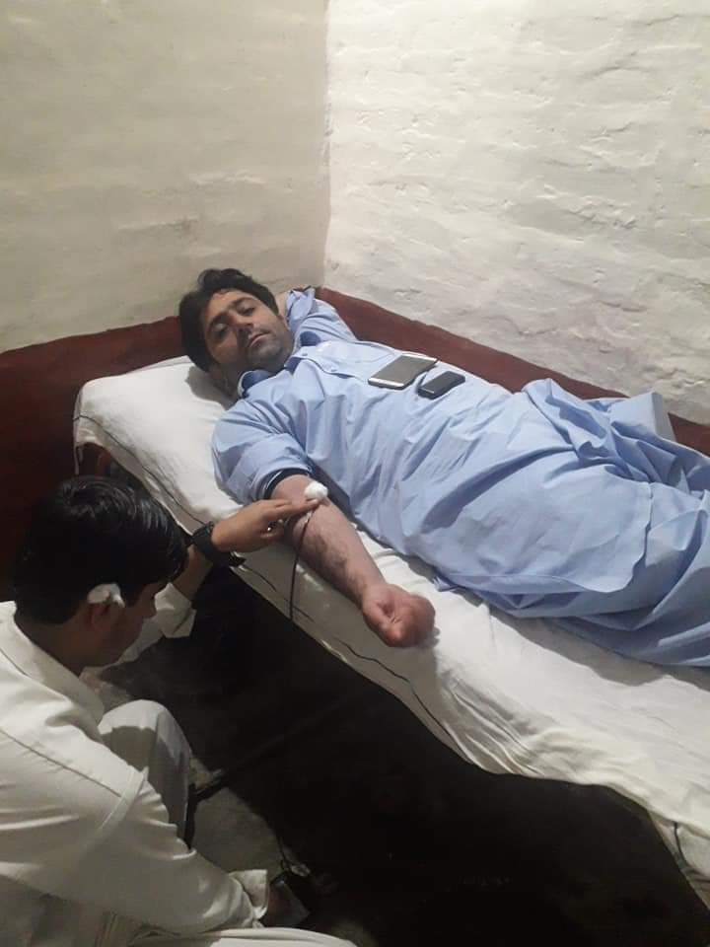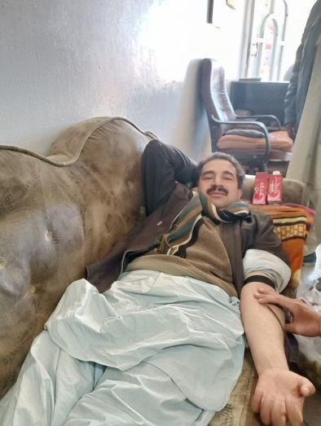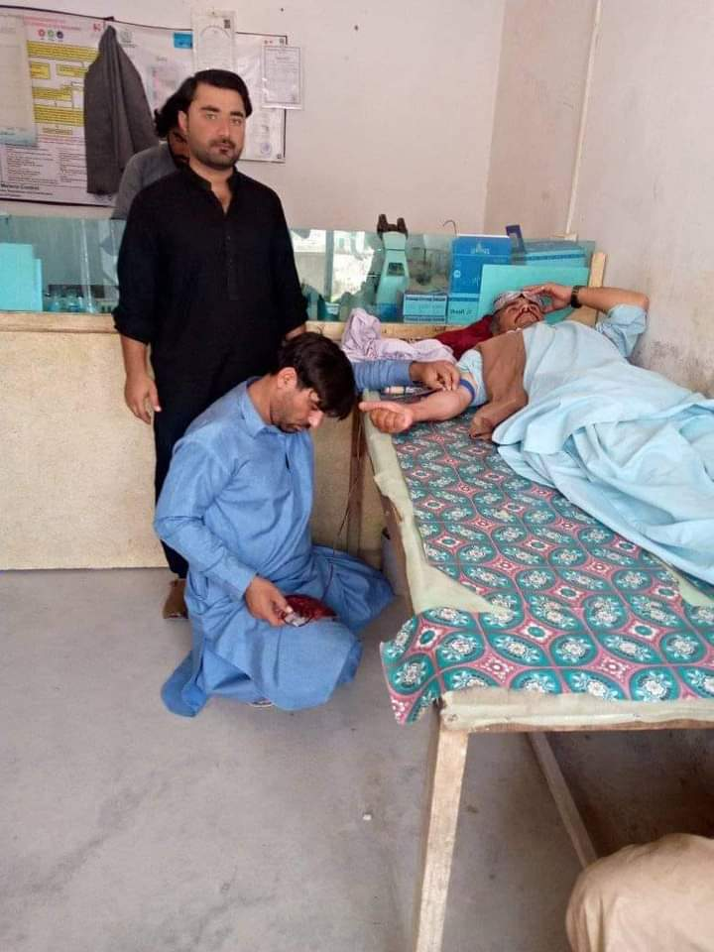
- COVID-19 and Awareness:
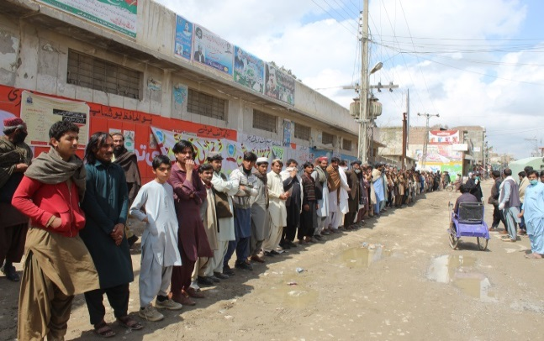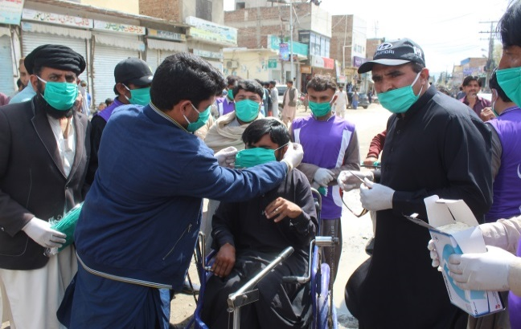

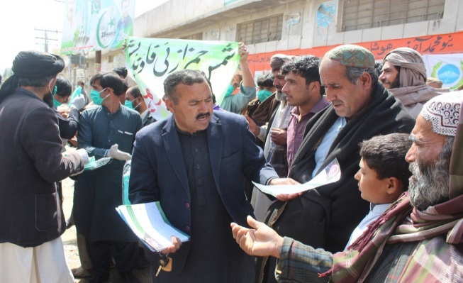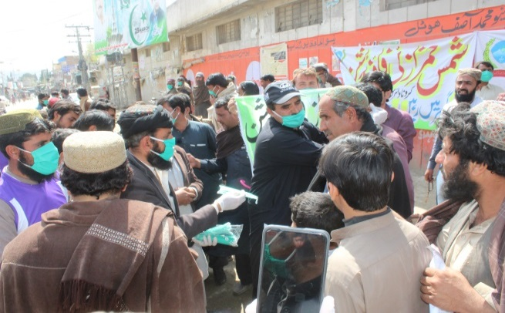

- Financial and Technical Assistance to Patients
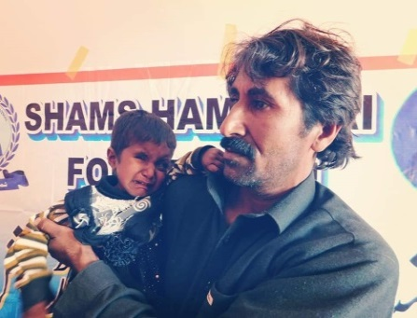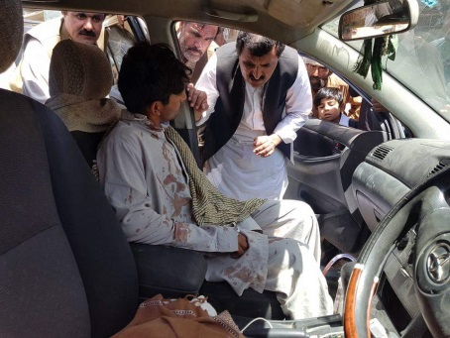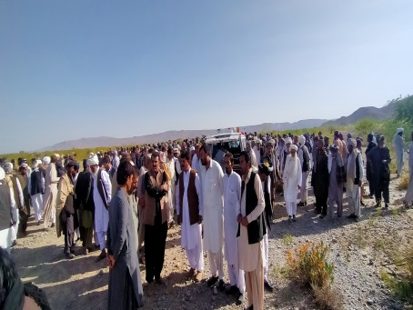

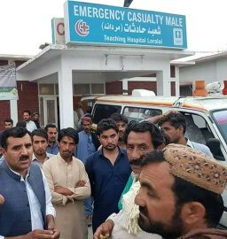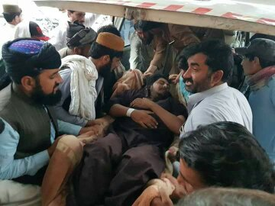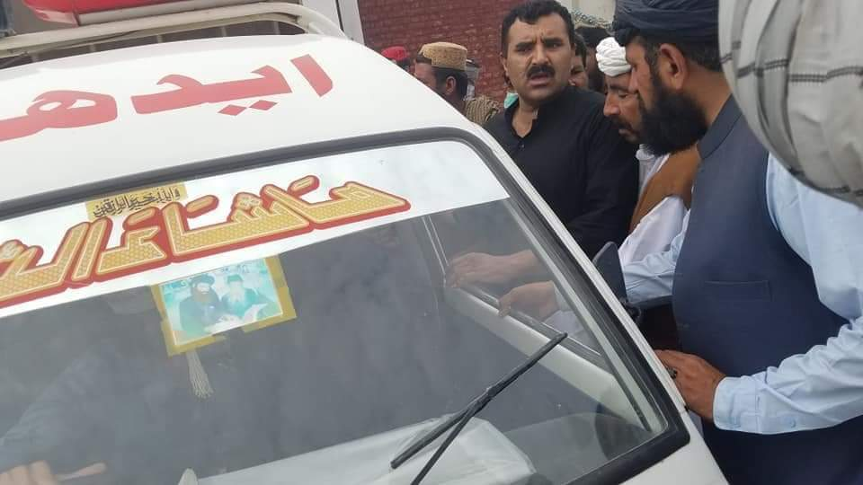

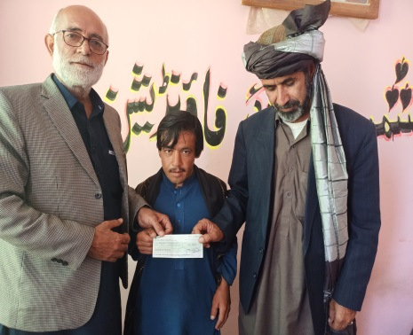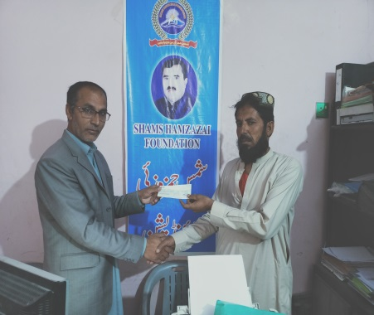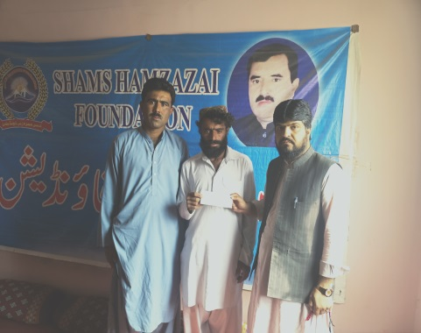
- Provide Medicines to Patient for his Assistance
- Poverty Elevation
SHF provides an opportunity of starting business to the deprived people of Balochistan. The activity has started recently on self-fundraising. 8/eight
- Raksha
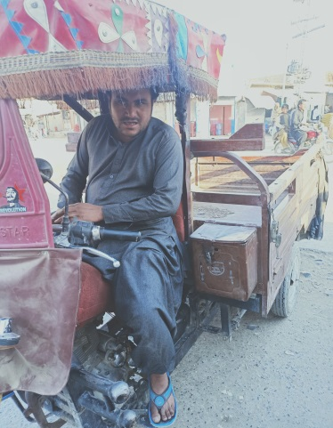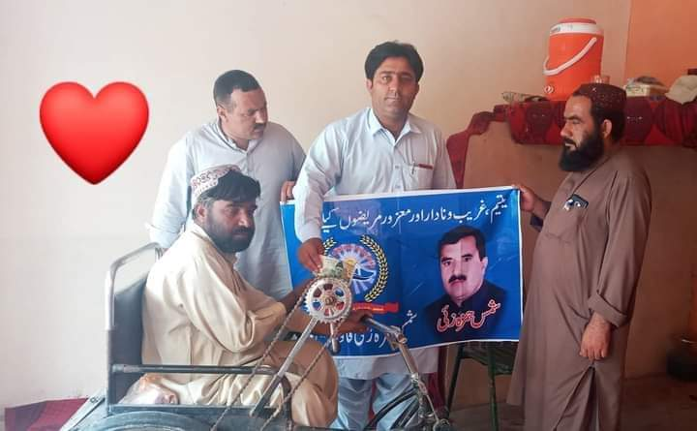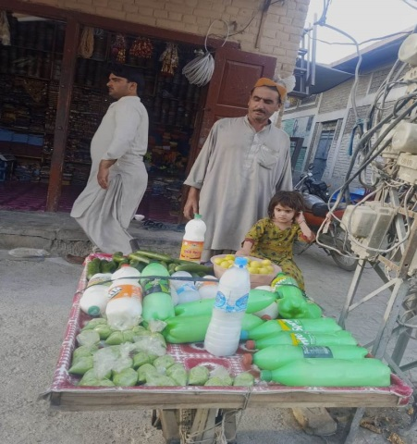
- Musical Tools
- Vegetable Stall
- Rashan Distribution
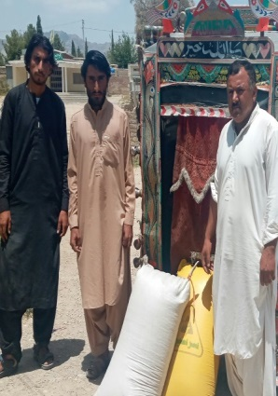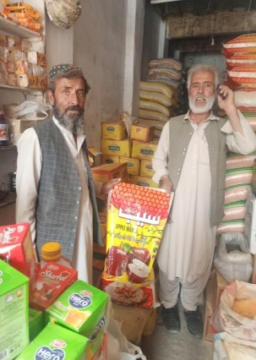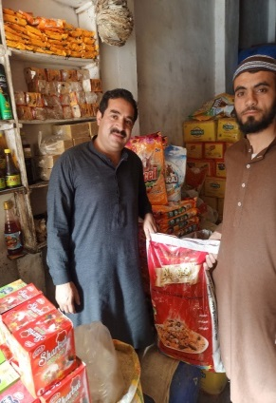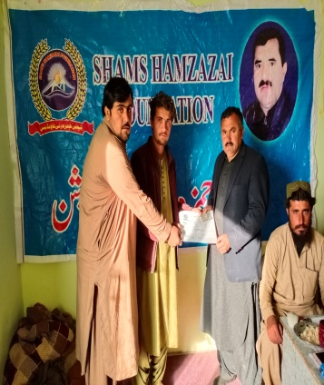
- Social Work
- CNIC Registration
The Shams Hamzazai Foundation has registered about 11,000 new and renewed identity cards. Registered more than 200 Locals
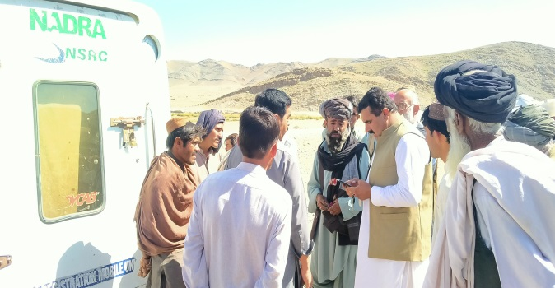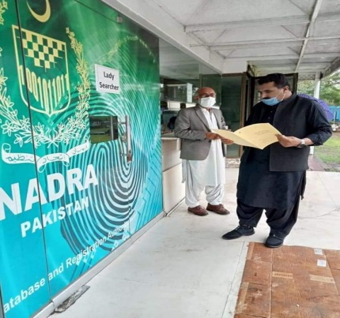
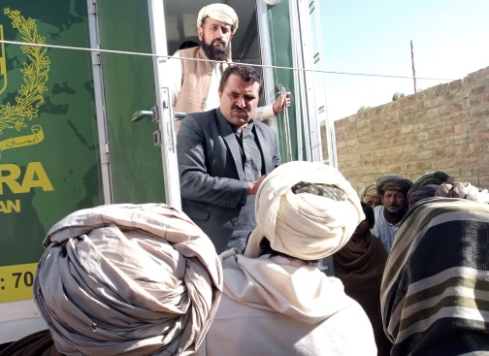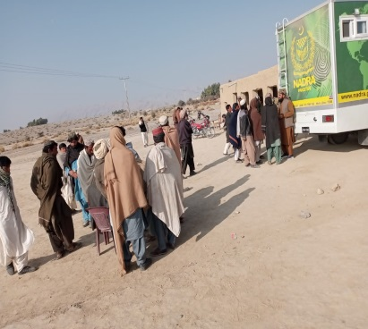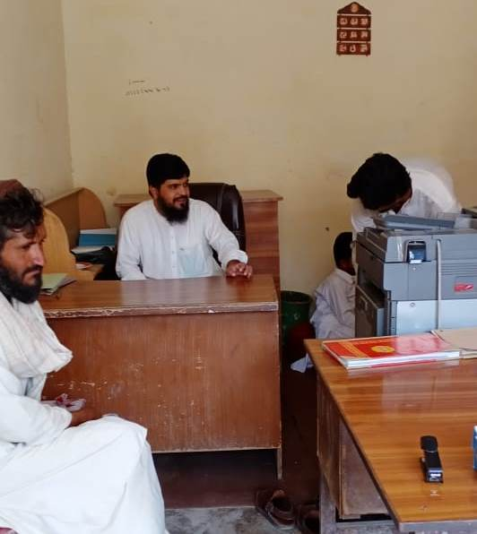
- Billed of different cases of the Civilian from Thana.
83 bills have been rented from the police station in various cases of citizens

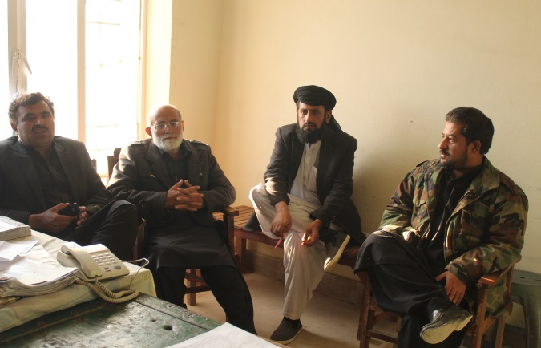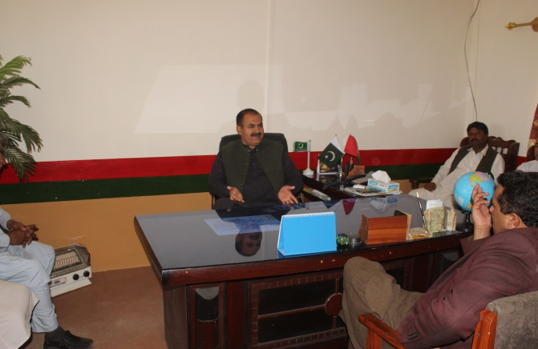
- Jarga / Conflict Resolution
49 small and large conflict resolutions have attracted people to peace.
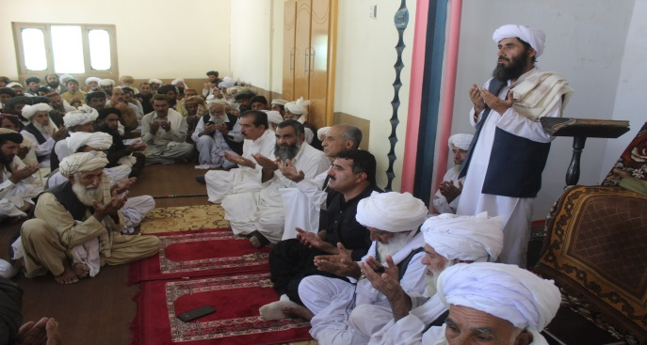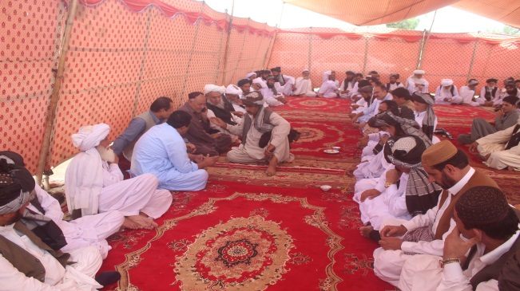
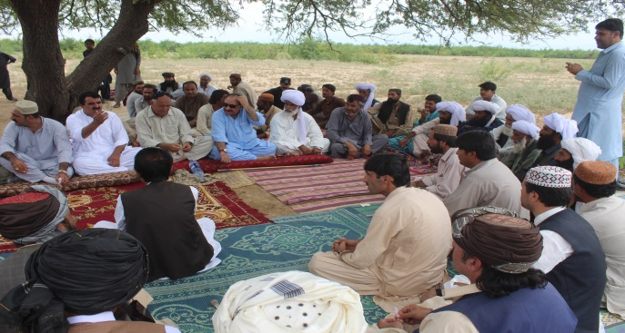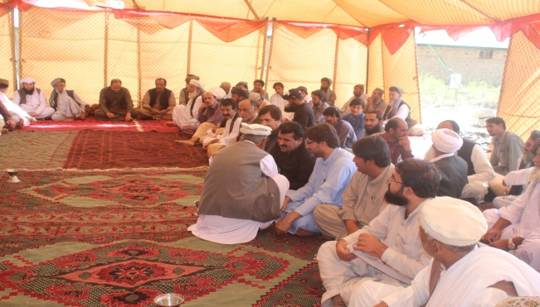

- Endowment Fund assisted in the process of Social Welfare Department
- Assistance in the process of Bait-ul-Mal form
- Social Mobilization
Nawabzada Mehboob Khan Jogizai Sardar Masood Khan Loni
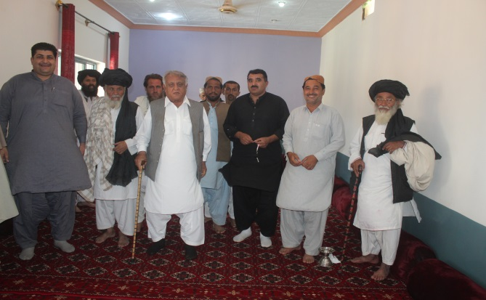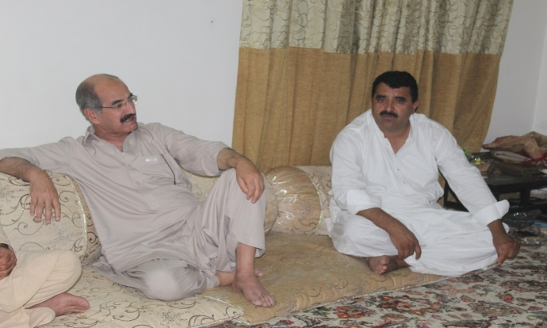

Mir Lashkari Raisani
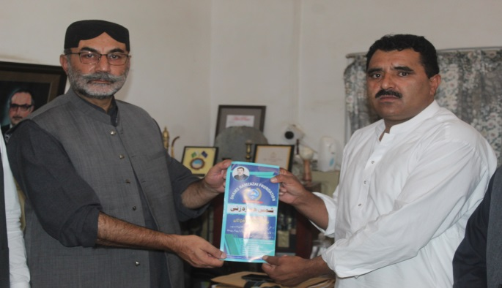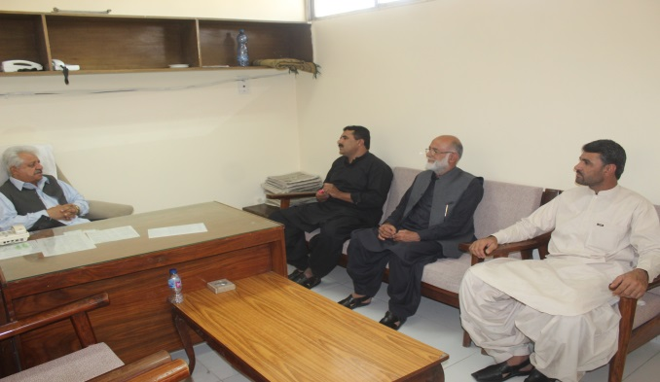

Sardar Babar khan Musakhail
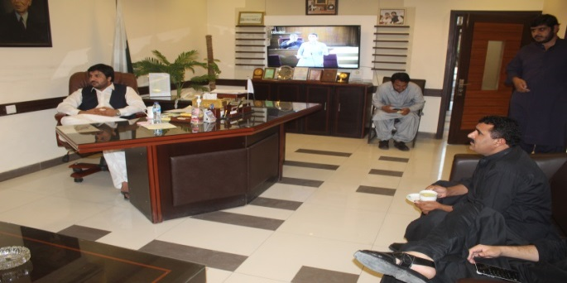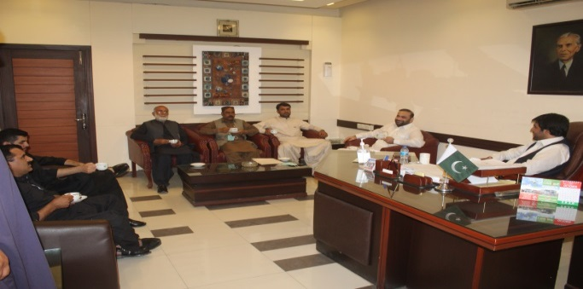

Nawab Ayaz Khan Jogizai
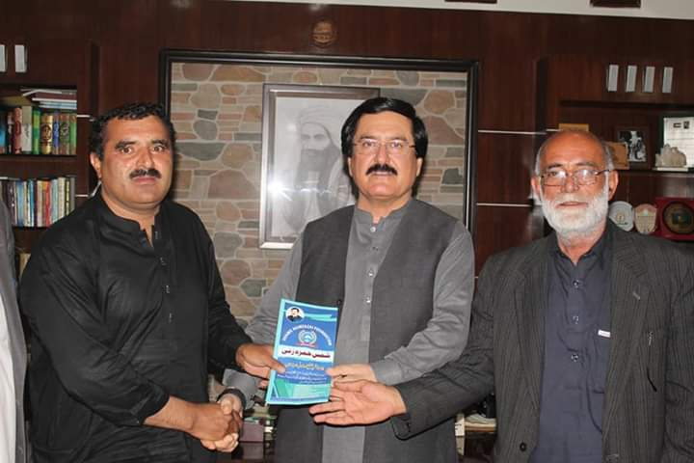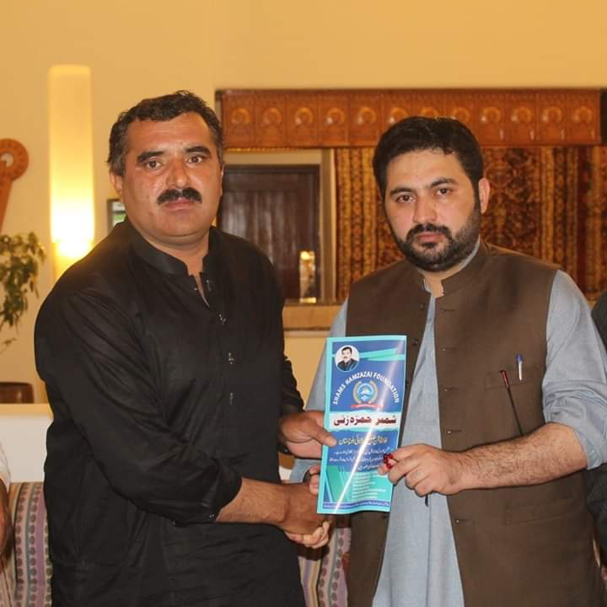

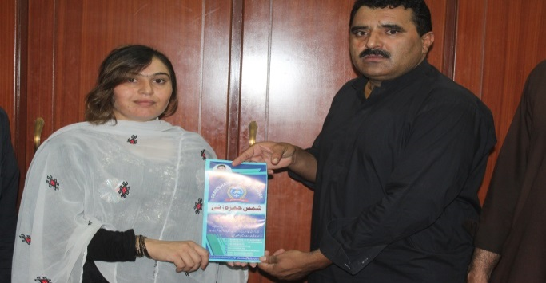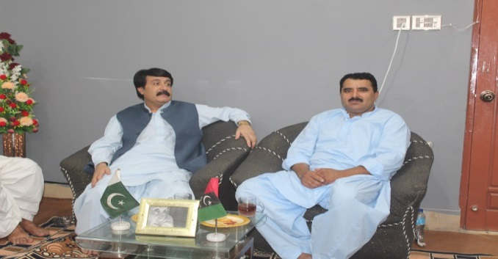

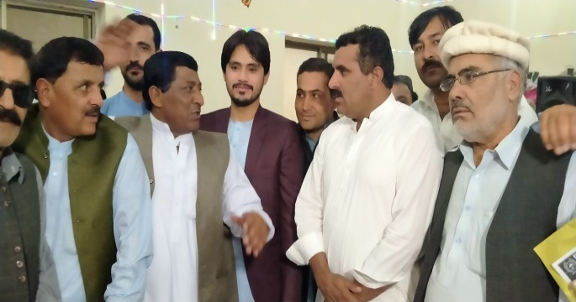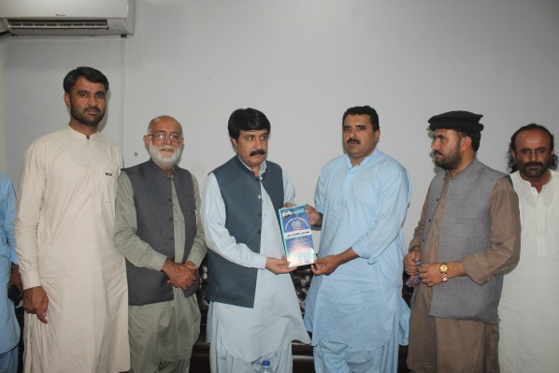
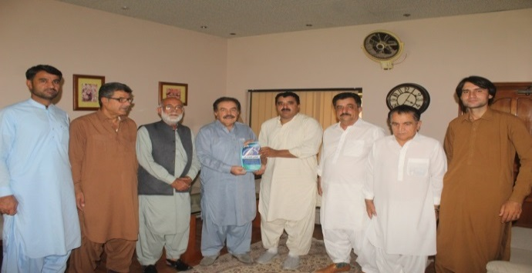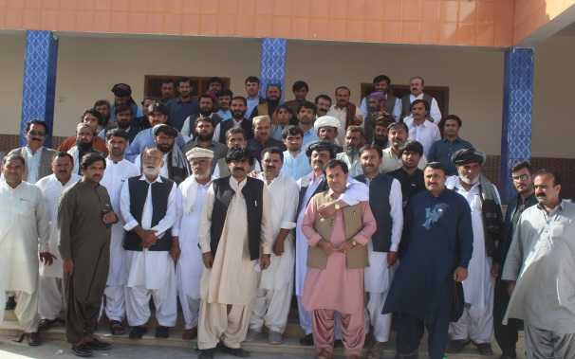
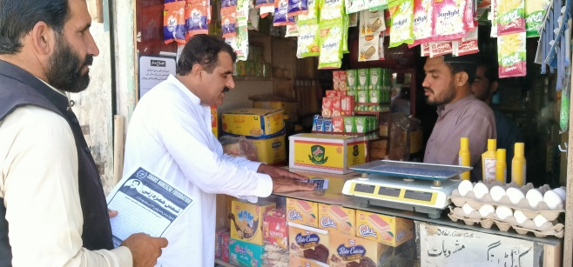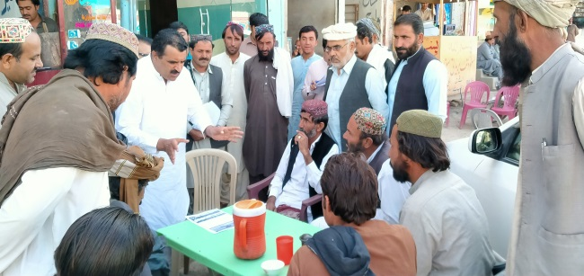
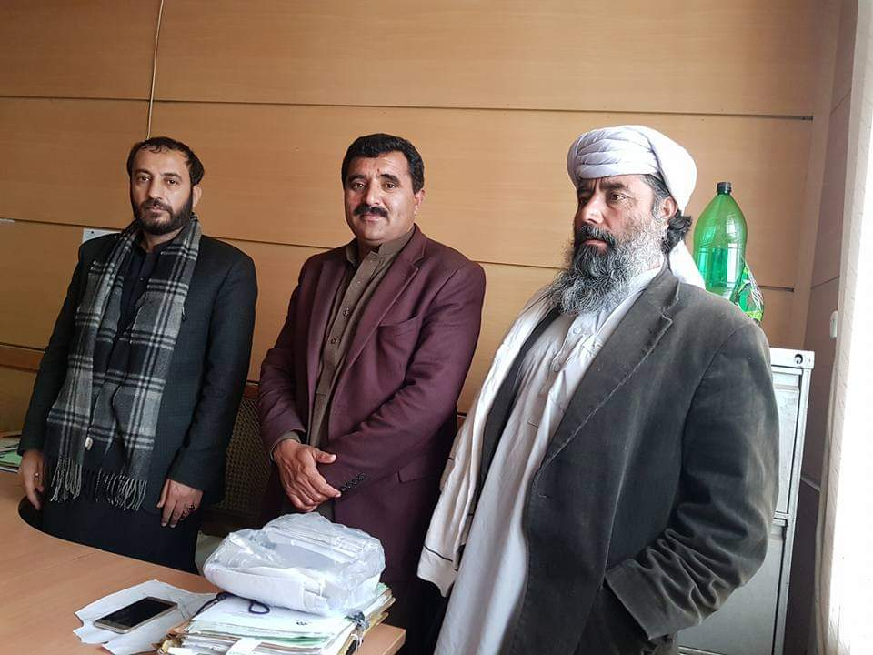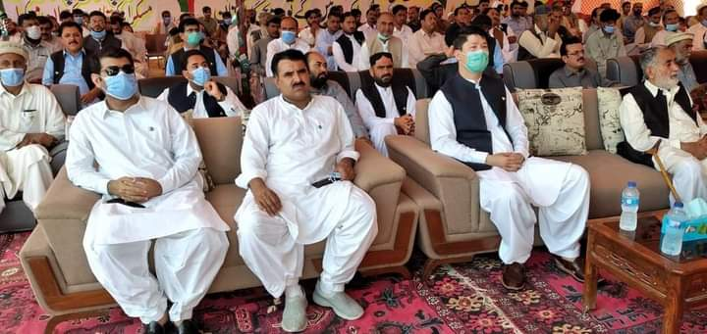
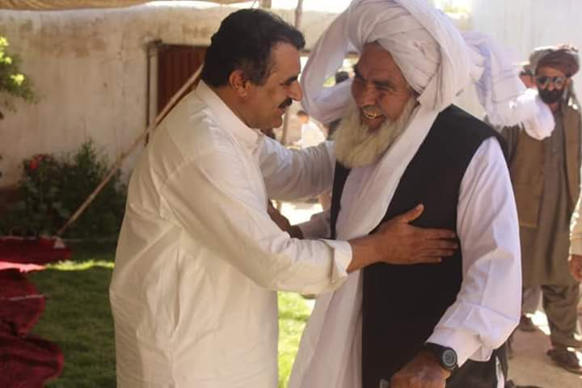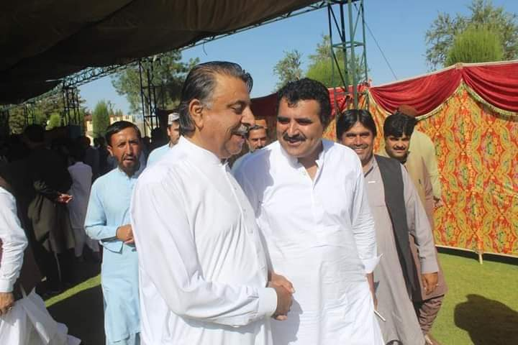
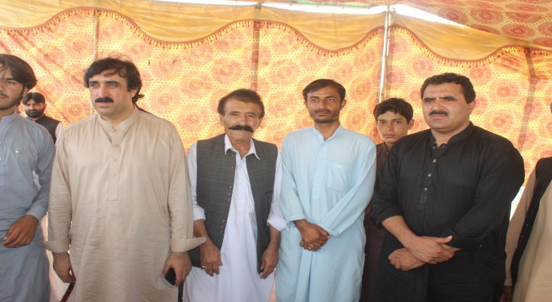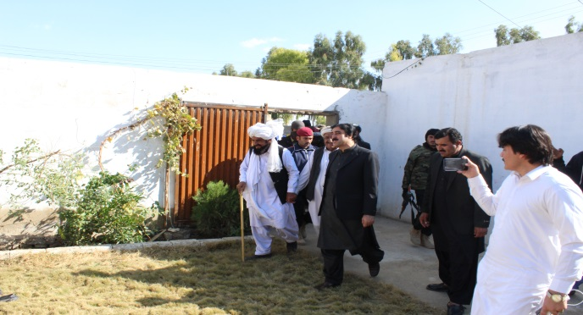
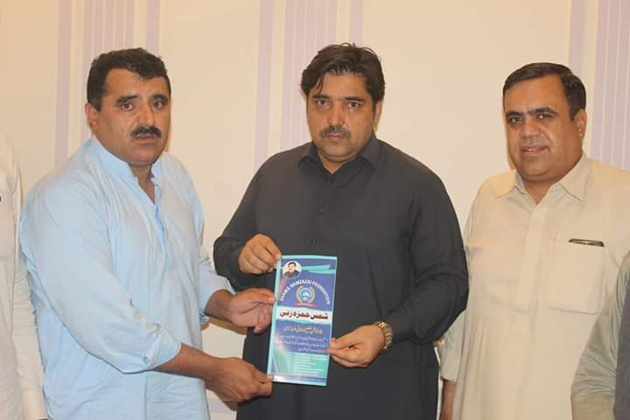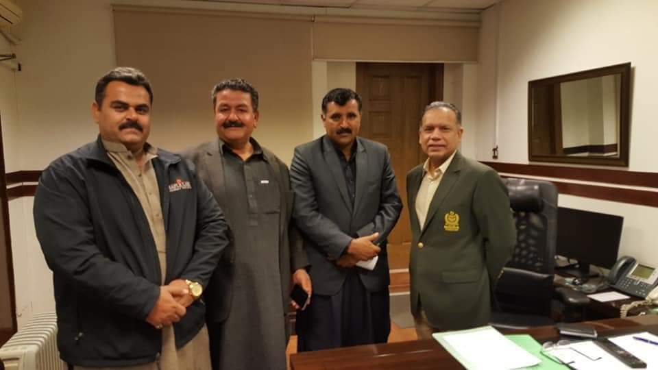
- Cultural Day Participation
Celebrating Cultural Day September 23 and participating in various cultural events.
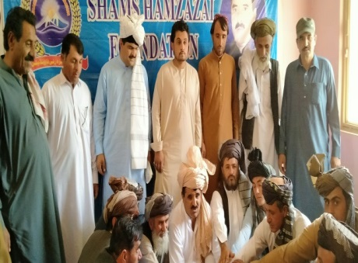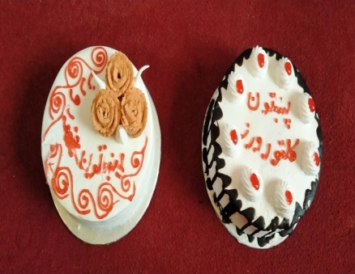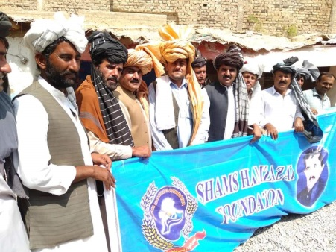

- Freedom Day Participation: Celebrate Independence Day and also participate in various programs.
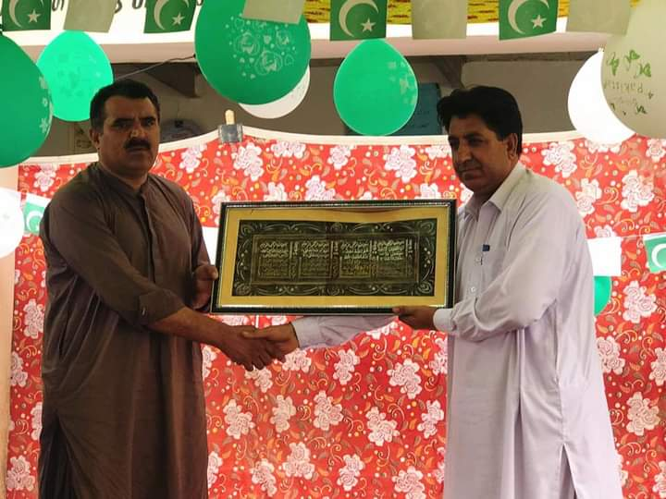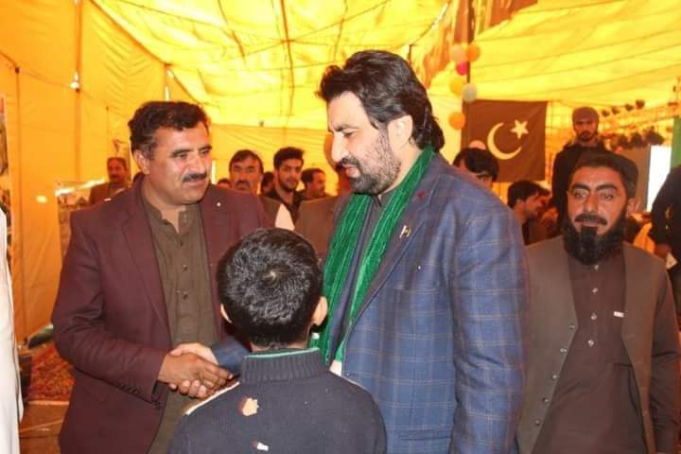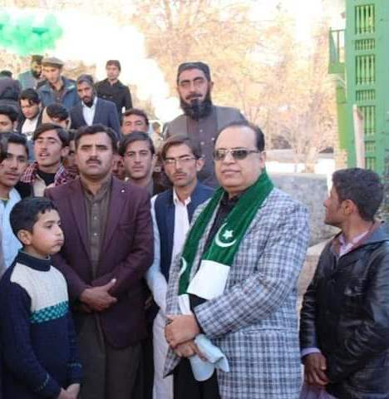
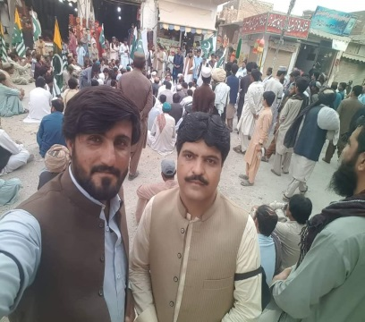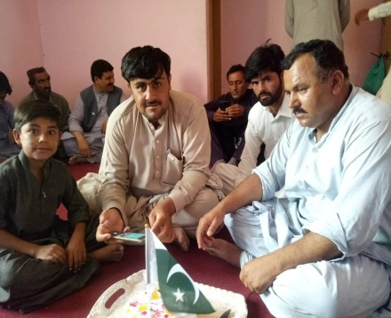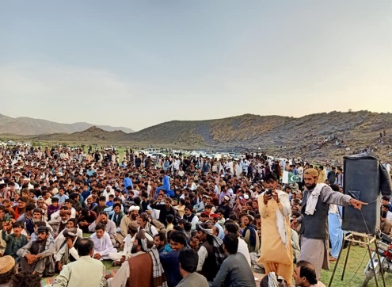
- Ehsaas Registration for Rashan/Cash: Enrolled 5500 people in Ehsaas Registration Ration / Cash Program
- Assistance in process of Endowment Fund: The endowment fund process is assisted to people in social Welfare Department.
- Bait-ul-Mal Form Assistance: Assistance in the process of Bait-ul-Mal form
- Excursions and fun
Provided financial assistance for 18 trips and recreation to children from different schools
- Sports
- Tournaments / Leagues: Assisted and Participated in 27 tournaments and leagues. Including financial support such as motorcycles, sports equipment and cash
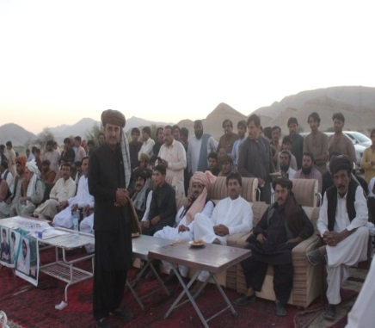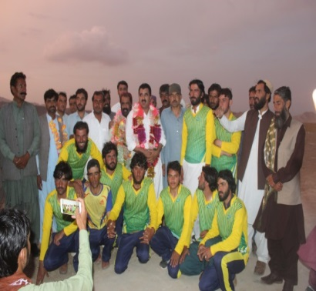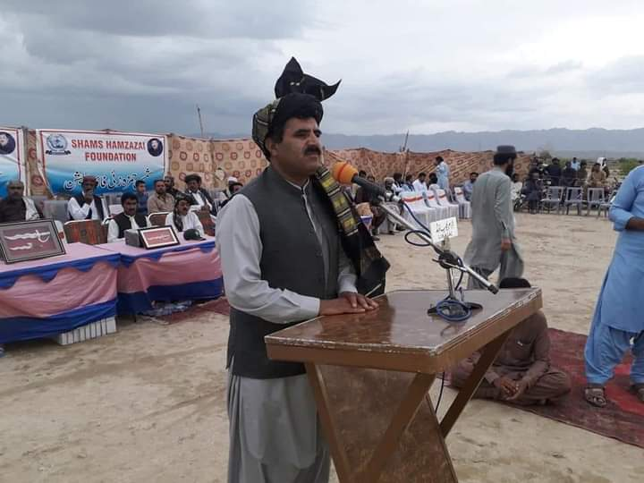
Our Partners
- Super Mekhtar Daewoo
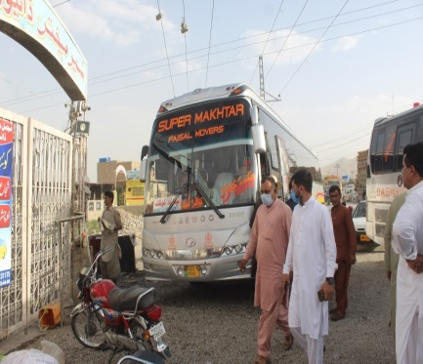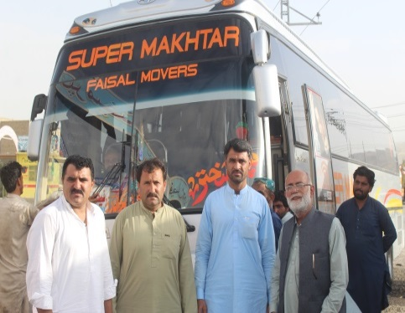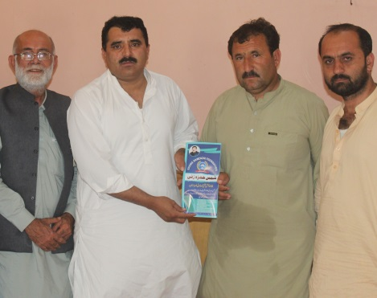
- Shams Hamzazai Mushtariqa Coal Mine Duki
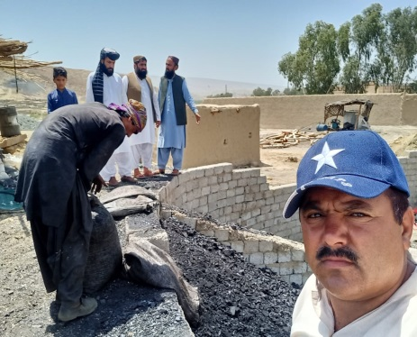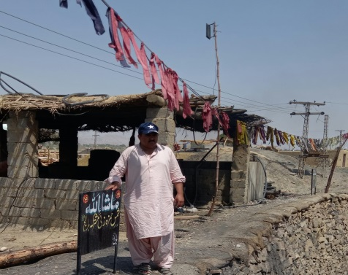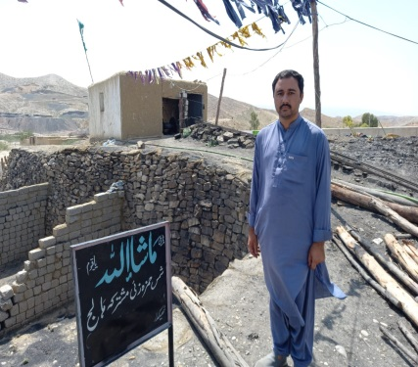
- Sardar Wali Khan and Shams Hamzazai Filter Marble Mine at Mahiwal Loralai
